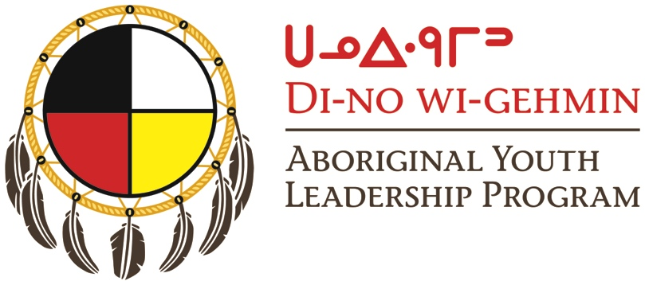

2017– 2018 Application Form
Contact Information:
Name: _____________________________________________________ Email address: ________________________________________
Address: _________________________________________________________________________ Postal Code: ______________________
Phone: _______________________________________ Date of Birth: _____________________ Sex: ____________________________
I identify as Indigenous to Canada: ___ First Nations ___ Inuit ____ Metis ___ Don’t identify
Please specify Nation/Community: ______________________________________
Student Status: ___ High School ___ Post-secondary ___ I’m not in school ____ Other

Letter of Intent:
Please complete a brief letter of intent/essay by answering the following four questions:
- In whatever way feels most comfortable to you, tell us “Who are you?” (ie. Activities, hobbies, interests, etc.)
- Why you would like to participate in the Di-No Wi-Gehmin Aboriginal Youth Leadership program?
- What do you think it means to be a good leader? What leadership skills do you already have?

- Is there anything else you would like to tell us? Please feel free to share anything else about yourself that you think is relevant to being a participant in this program.

Tell Us:
Where did you learn about the Di-No Wi-Gehmin Aboriginal Youth Leadership program?

If you have any questions about the program or the application contact Rebecca Johnson at 577.2807
or through email at rjohnson@thunderbay.ca
Miigwetch for your interest.
Please email this form and your answers to the above questions to info@leadershiptb.com

Brought to you as a partnership between
Thunder Bay Indian Friendship Centre

